How to Put on a Sofa Cover
Step 1 Remove Sofa legs/bases before putting on sofa covers.
Step 2 Start from the armrest part always. Make sure the front and back corners of armrest fit with the cover.
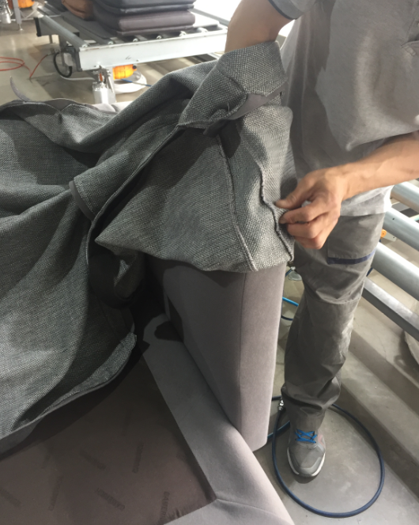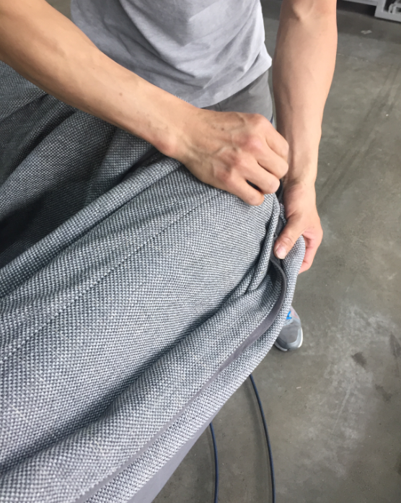

Step 3 Then put the cover on backrest, smooth the wrinkles by hands from one side to another.
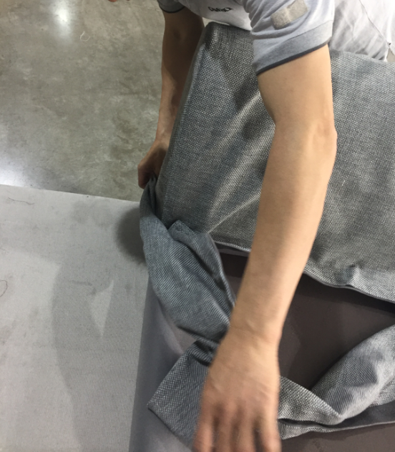

Step 4 Take off the Velcro covers and affix the cover on the grey fabric lining.
You can use a ruler when putting the cover on the corner between armrest and backrest.
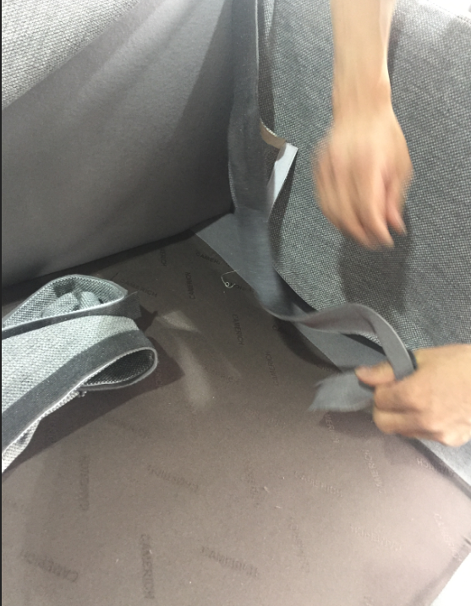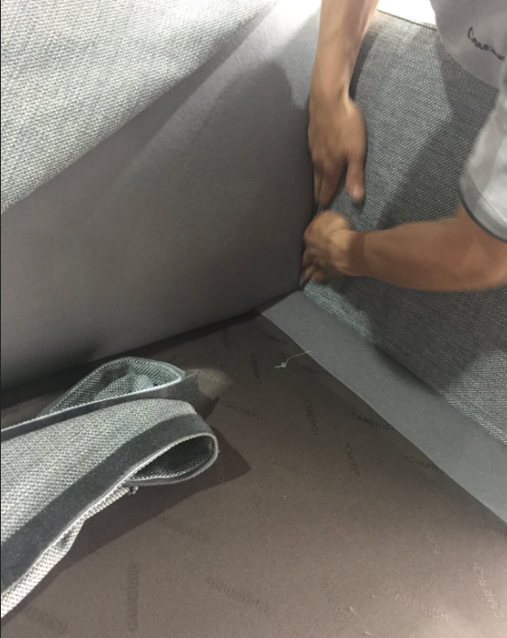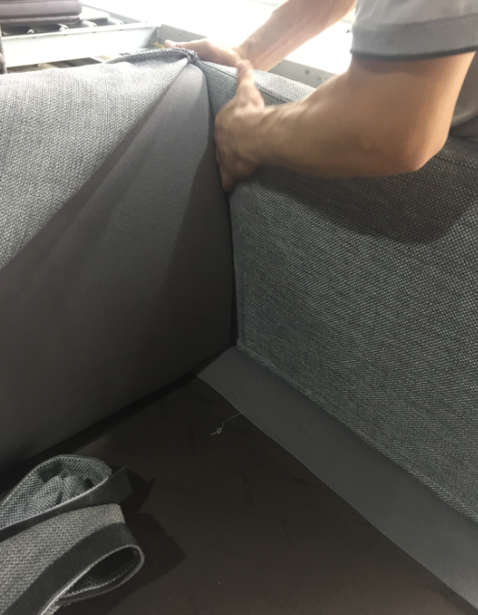
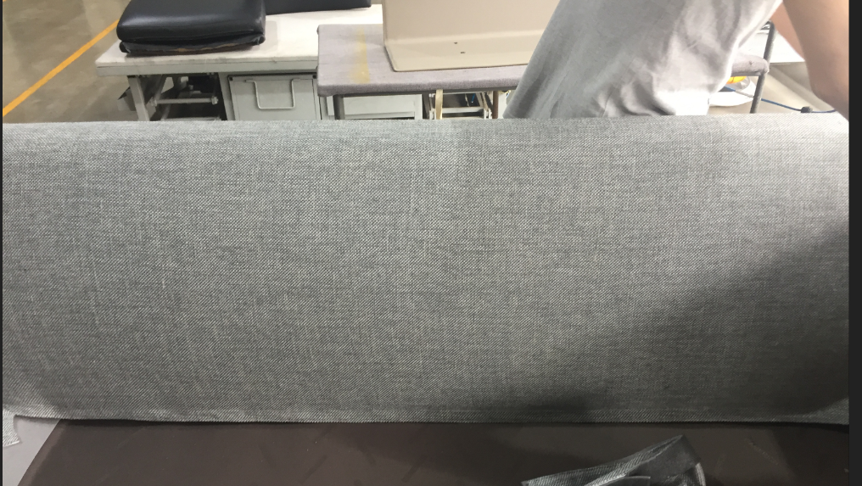
Step 5 Then do the base part. Same step as doing armrest and backrest.
