Tips for Installing Solo Cabinet
- Top Installation
- If the positioning of holes on the top board is slightly off, and the top board cannot be installed, try pulling out the 4 dowels, (circled below in red).
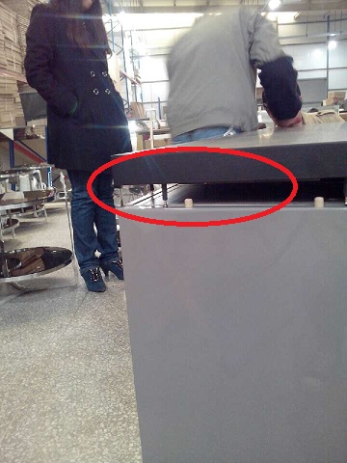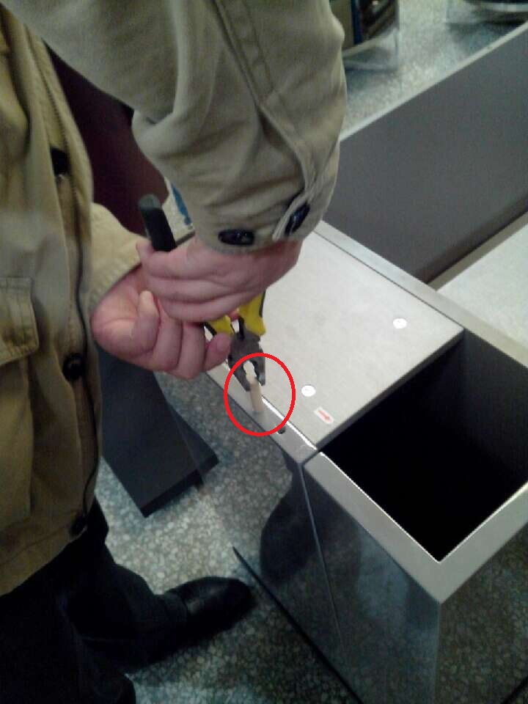

- If there is still a gap underneath the top board, this can be rectified by applying pressure onto the top board, (we recommend a rubber hammer for this).
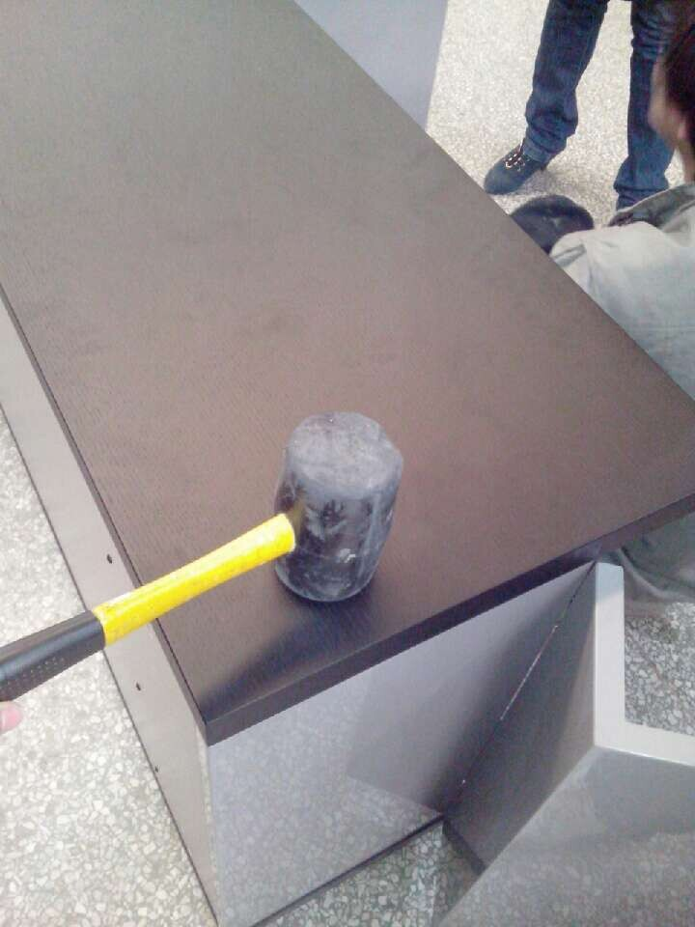
B. Door Installation
a. Installing the hinge in proper order is important; we suggest fitting the lower hinge first, and then following the below steps to install the upper hinges.

- Push the hinge so it is as close to the door as possible.
- Fit screw B into the hinge, do not tighten it.
- Fit screw A onto the board while it is in the proper position.
- Tighten screw B only after the door closes correctly.
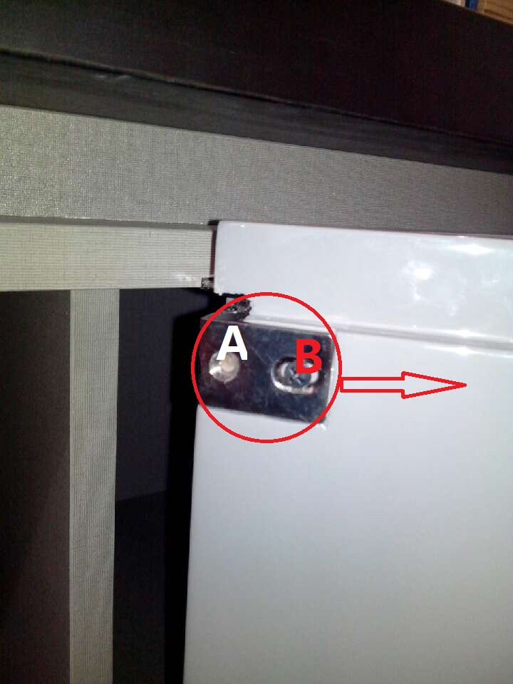

b. Problems may arise when installing the doors:
- Doors are Not Aligned
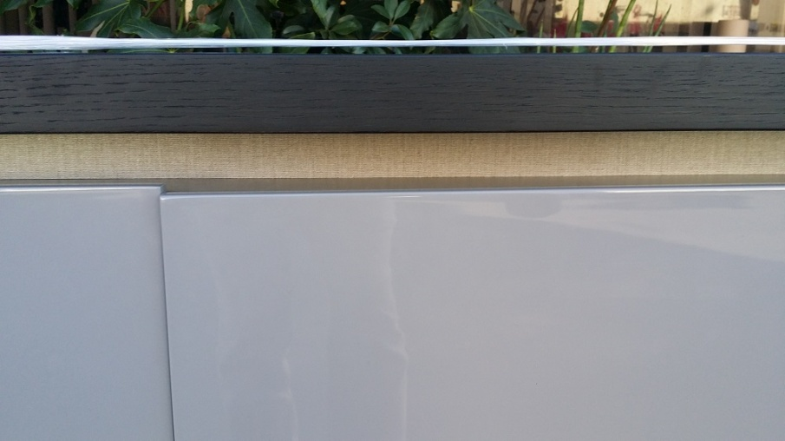
Loosen screw A first, then adjust screw B. Note that the hole on hinge for screw B is larger, allowing enough room to adjust screw B to the proper position.

- Gap between 2 Doors.
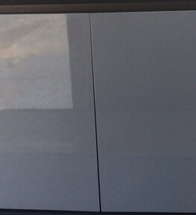
Adjust this particular part of hinge, (circled below in red). This will fix any issues with gaps between the doors.
