Tips for Installing Unity Table

This is the supplement for the install instruction for Unity table.

Step 1: Install support brackets to the base with 16 screws (M8*110) and 1 screw (M8*50).

Tips: Fit one screw into the hole on each side. DO NOT tight it until other three screws fit properly.
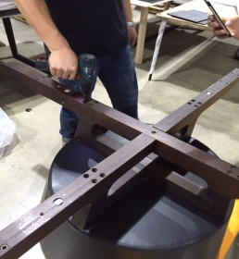

Step 2: Install Lazy Susan to the support brackets with 4 screws (M8*110) & 4 washers of metal (M9).

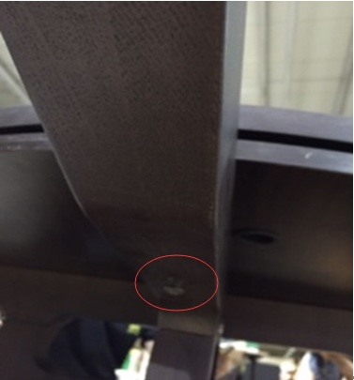

Tips: DO NOT tight them until the completed table installation is finished.

Step 3: Install metal plates to the support brackets with 16 screws (M8*20).
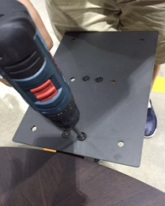
Step 4: Connect 2 outer table top with 4 dowels and 4 connection hardware (ø35*M10)
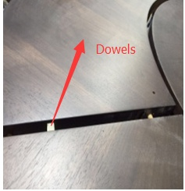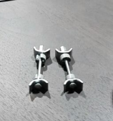

Tips: When placing the outer table top to the metal plates, make sure the connected area to be placed as closer as possible to the metal plates. See below: 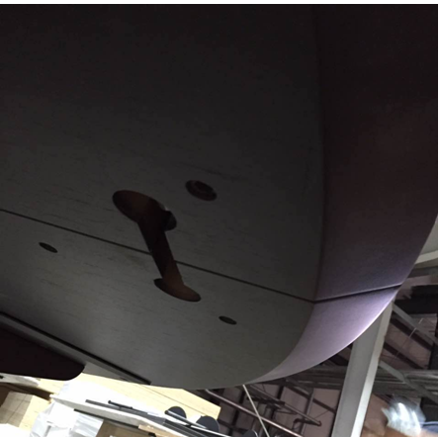
Step 5: Fasten the connection hardware with open-end wrench (M10).
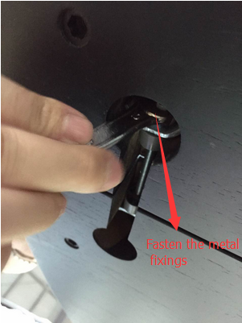

Step 6: Move the outer table top until the connected area right on the metal plates, make sure all holes aligned
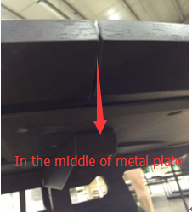

Step 7: Install outside table top to the metal plates with 24 screws (M8*20).
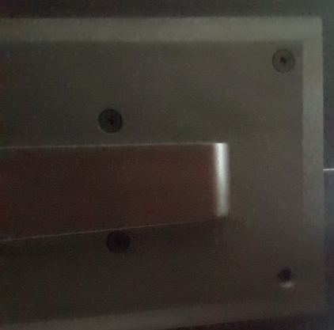
Step 8: Tighten 4 screws ( M8*110) underneath the support brackets if it’s even. If not, adjust the pre-built hardware with Allen wrench (M4) shown below

